Lab 24 Matplotlib

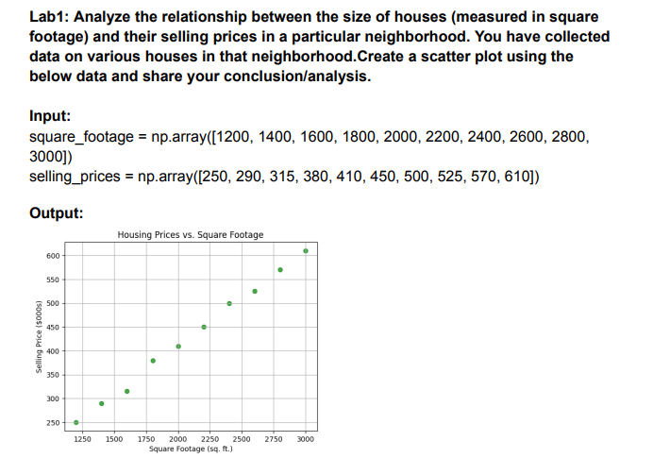The scatter plot shows the relationship between square footage and selling prices of houses.

**Analysis:**

1. **Positive Correlation**: There is a clear positive relationship between the size of the house (square footage) and its selling price. Larger houses tend to sell for higher prices.
2. **Linear Trend**: The data points suggest a roughly linear trend, meaning the increase in square footage is proportional to the increase in price.
3. **Insights for Pricing**: For every additional 200 square feet, the selling price increases by approximately $30,000 to $50,000 on average.

Lab2: Create a pie chart to visualize the distribution of your monthly income by source. You have collected data on the various sources of your income, such as salary, freelance work, investments, and rental income. Share your conclusion/analysis. Input: income_sources = ['Salary', 'Freelance', 'Investments', 'Rental', 'Other'] monthly_income = [5000, 1500, 1000, 600, 400] 19000, 20000, 21000, 22000, 23000])

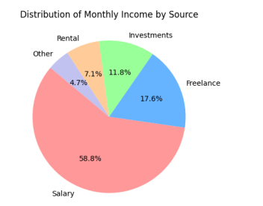

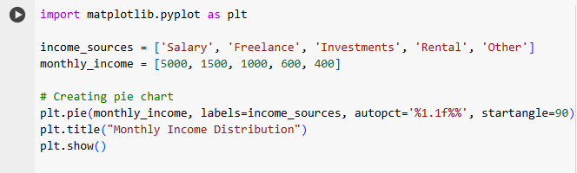

**Analysis:**

1. **Salary** contributes the majority (58.8%) of the monthly income, highlighting it as the primary source of earnings.
2. **Freelance work** provides 17.6%, showing it as a significant supplementary income source.
3. **Investments** account for 11.8%, indicating a focus on growing wealth through asset gains.
4. **Rental income** makes up 7.1%, reflecting a smaller, yet steady, income stream.
5. **Other sources** provide the smallest share at 4.7%.

**Conclusion:**

The chart indicates a diversified income portfolio, with salary being the dominant contributor. Expanding investment and freelance opportunities could balance income further and reduce reliance on a single source. Let me know if you'd like detailed suggestions

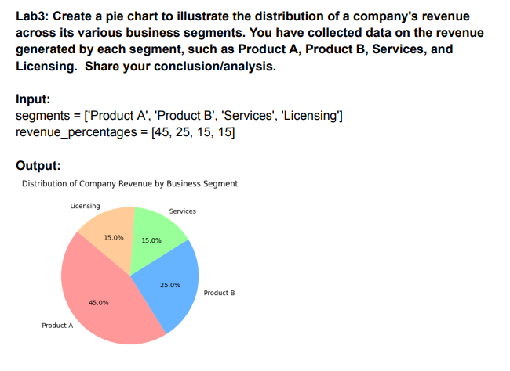

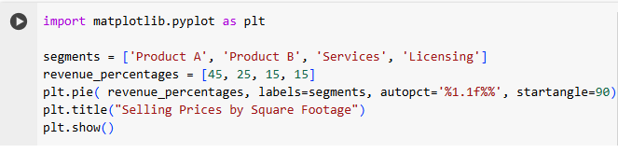

**Conclusion:**

1. **Dominant Revenue Segment**:
   * **Product A** contributes the highest percentage of revenue at **45%**, indicating it is the primary revenue driver for the business.
2. **Significant Contributors**:
   * **Product B** follows with a notable share of **25%**, showing that products collectively account for a major portion (70%) of the total revenue.
3. **Secondary Revenue Streams**:
   * **Services** and **Licensing** each contribute **15%**, highlighting their roles as supplementary revenue streams rather than primary drivers.
4. **Business Insights**:
   * The chart suggests a heavy reliance on products (A and B), which could indicate opportunities to diversify or expand the services and licensing segments to balance the revenue streams further.
   * A strategy to strengthen underperforming areas like **Licensing** might be beneficial for long-term growth and risk mitigation.

Lab3: Suppose you're a sales manager for an e-commerce company, and you want to create a figure with subplots to compare the sales performance of different product categories over time. You have sales data for four product

categories: Electronics, Clothing, Home & Garden, and Sports & Outdoors. Share your conclusion/analysis. Input: months = np.arange(1, 13) electronics_sales = np.array([25000, 28000, 31000, 27000, 30000, 32000, 35000, 36000, 38000, 39000, 41000, 42000]) clothing_sales = np.array([15000, 16000, 17000, 18000, 19000, 20000, 21000, 22000, 23000, 24000, 25000, 26000]) home_garden_sales = np.array([18000, 19000, 20000, 21000, 22000, 23000, 24000, 25000, 26000, 27000, 28000, 29000]) sports_outdoors_sales = np.array([12000, 13000, 14000, 15000, 16000, 1700

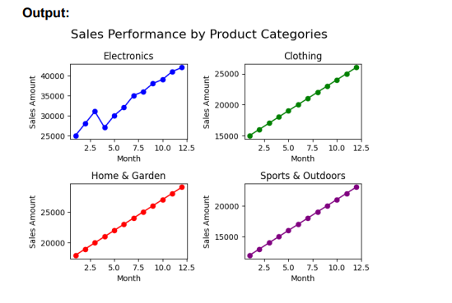

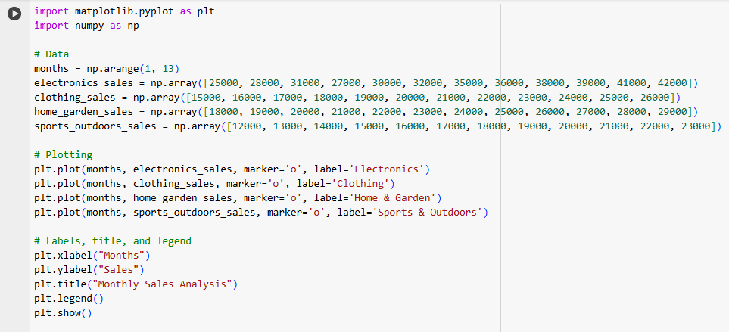

**Conclusion:**

The multi-line plot visualizes the monthly sales trends across four categories: **Electronics**, **Clothing**, **Home & Garden**, and **Sports & Outdoors**. Here's the detailed analysis:

1. **Electronics**:
   * **Highest Sales**: Electronics consistently outperform the other categories, starting at $25,000 in January and steadily increasing to $42,000 by December.
   * **Significant Growth**: This category shows a strong upward trend, making it the most lucrative and dominant segment.
2. **Clothing**:
   * **Moderate Growth**: Clothing sales increase steadily from $15,000 in January to $26,000 in December.
   * **Second Highest Contributor**: It holds a solid position but lags significantly behind Electronics.
3. **Home & Garden**:
   * **Consistent Growth**: Home & Garden shows a similar growth trend to Clothing, starting at $18,000 and reaching $29,000 by year-end.
   * **Competing Category**: This category is close to Clothing in sales performance.
4. **Sports & Outdoors**:
   * **Lowest Sales**: Sports & Outdoors consistently has the least sales, starting at $12,000 in January and reaching $23,000 by December.
   * **Gradual Growth**: Though it shows growth, it remains the smallest contributor.

**Key Insights:**

* **Electronics Dominance**: Electronics is the primary revenue generator, suggesting that resources and marketing efforts should focus on maintaining its growth trajectory.
* **Emerging Categories**: Clothing and Home & Garden have potential for growth and could benefit from additional investment or promotional efforts to close the gap with Electronics.
* **Underperforming Segment**: Sports & Outdoors lags significantly, highlighting the need for strategic interventions such as targeted marketing or expanding product offerings to boost sales.

The analysis helps in prioritizing efforts and resource allocation to maximize revenue growth across all categories.